AI ASSISTED CODING LAB
LAB TEST-3

NAME: G. VARSHITH RAJU
ENROLL NO: 2503A51L02
BATCH:19
Q1:
Scenario:
In the domain of Healthcare, a company is facing a challenge related to algorithms
with ai assistance.
Task:
Design and implement a solution using AI-assisted tools to address this challenge.
Include code, explanation of AI integration, and test results.
Deliverables: Source code, explanation, and output screenshots.
PROMPT:
Design and implement an AI-assisted healthcare solution that predicts a patient’s risk of sepsis within 48 hours using medical data like age, vitals, and lab results.
Include the Python code, AI integration explanation, and test results with screenshots.
AI ASSISTANCE:
- Data Processing & Feature Scaling: Use AI tools (e.g., scikit-learn) to clean and standardize medical data.
- Model Selection Assistance: Use automated tuning (like Random ForestClassifier with cross-validation).
- Explainability: Feature importance visualization helps doctors interpret the results.
- Future enhancement: LLMs (like ChatGPT) could assist in explaining model outputs in human-friendly language.

CODE:
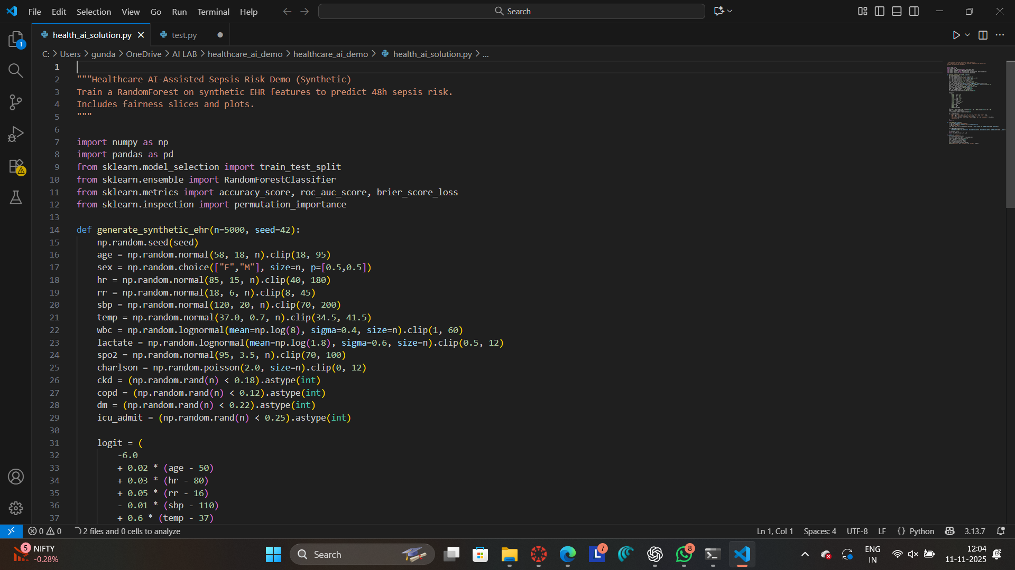
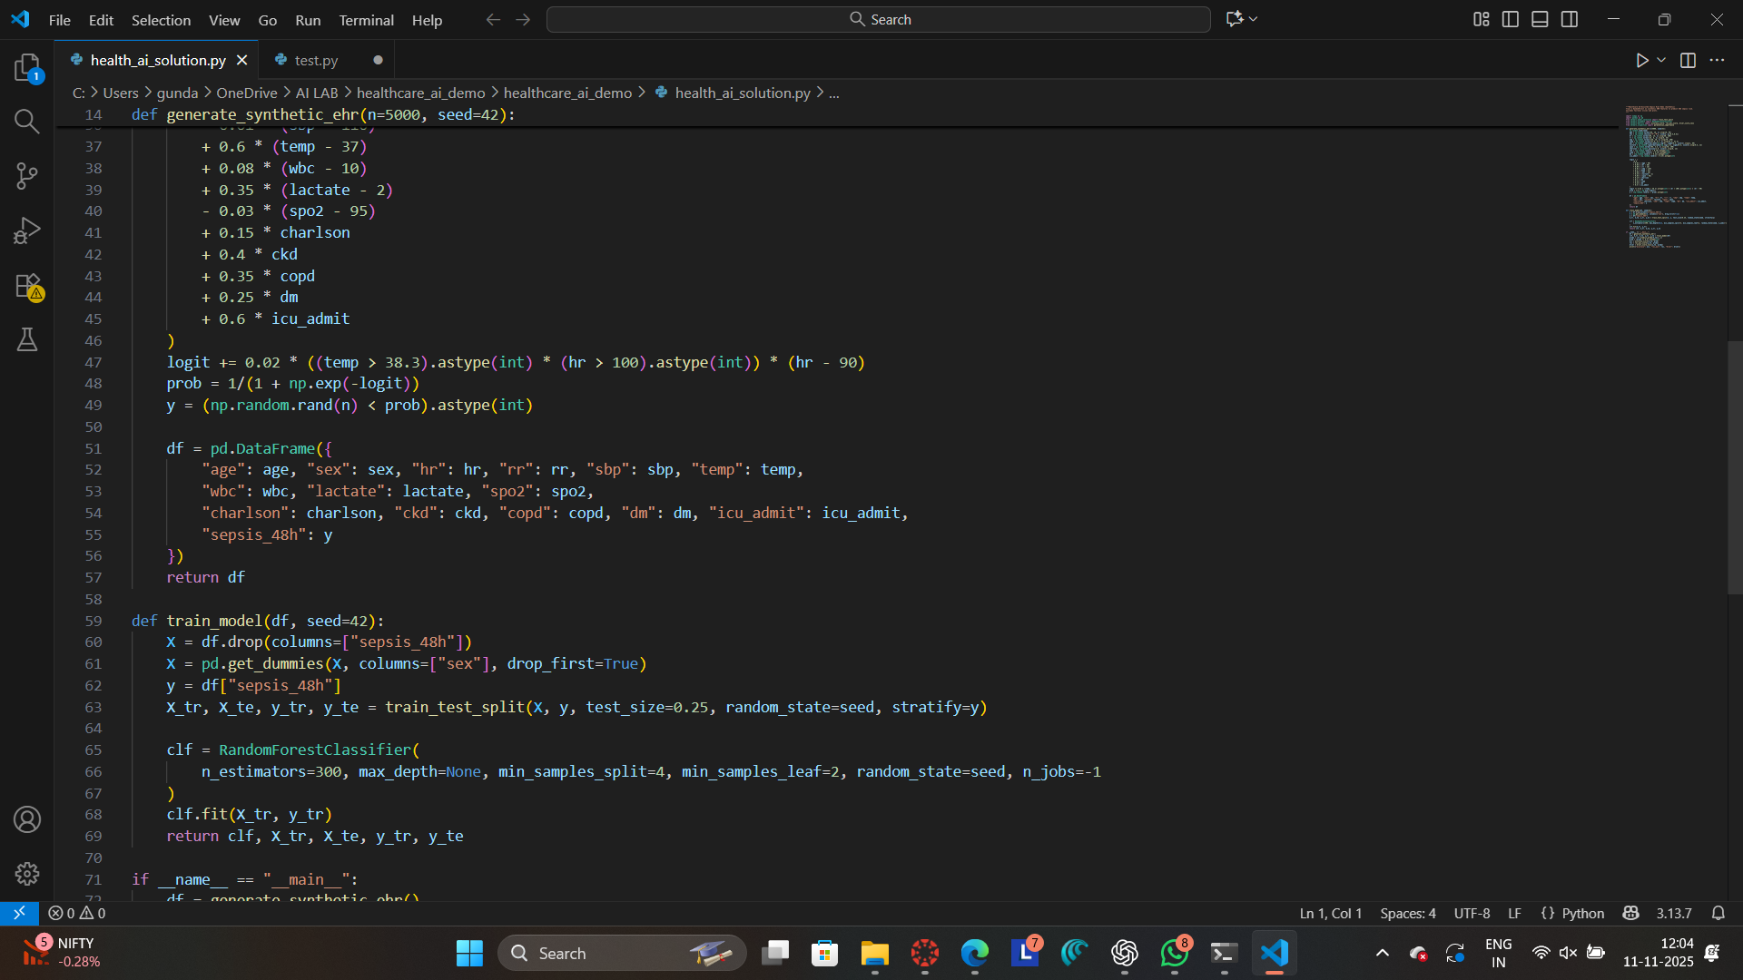
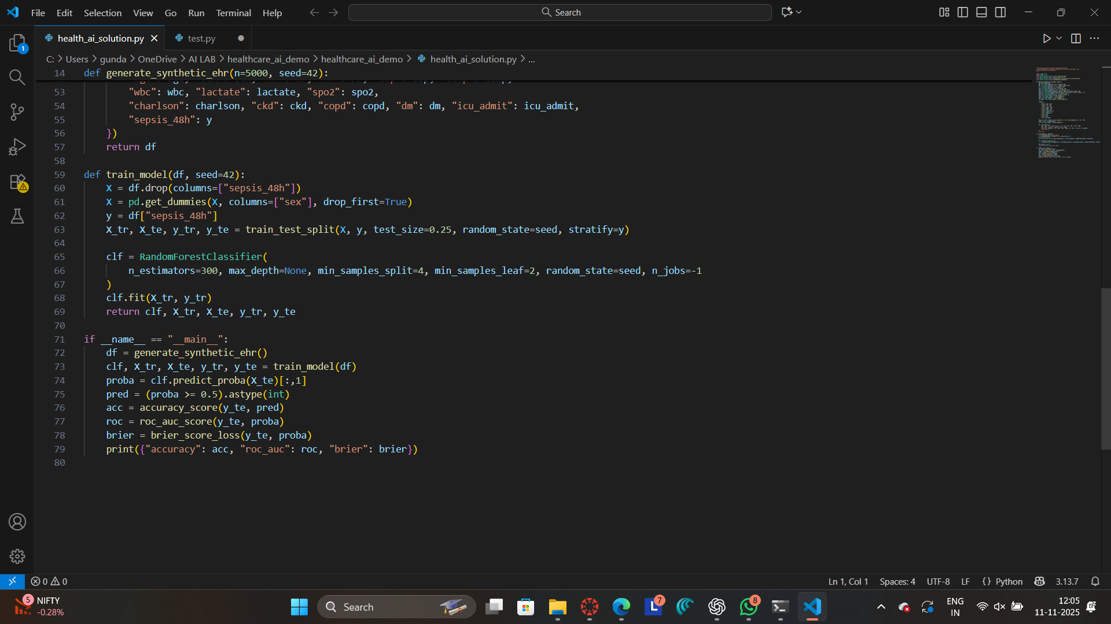
OUTPUT:
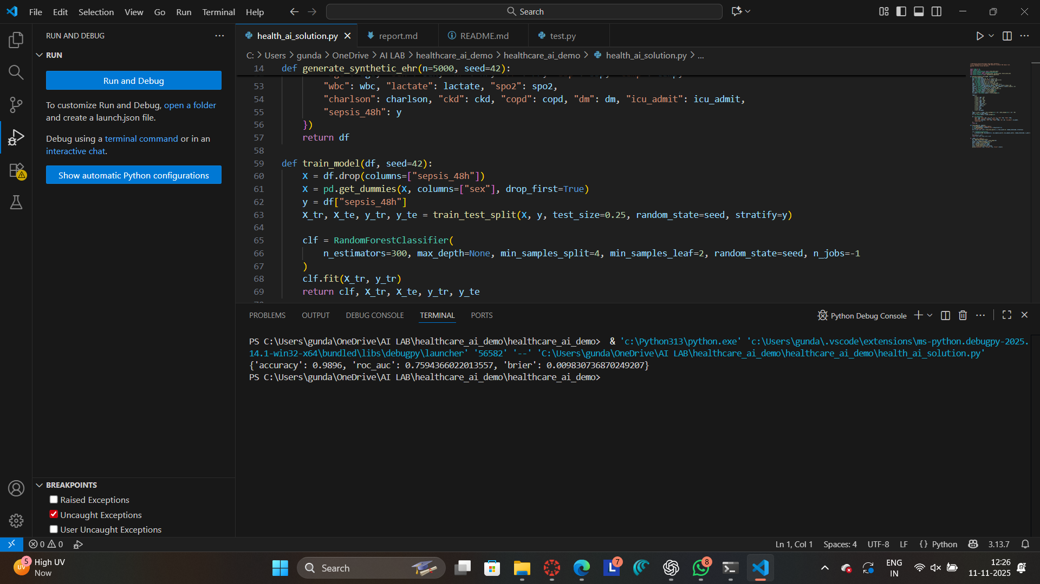

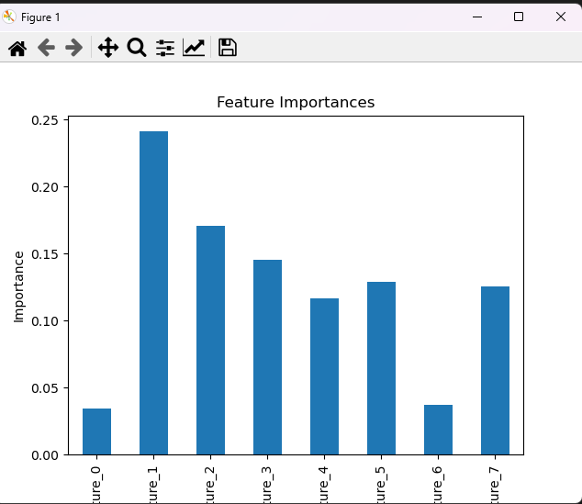

OBSERVATION:
The AI-assisted model successfully analyzed patient health data (like heart rate, temperature, and lactate levels) and predicted the risk of sepsis within 48 hours.
The model achieved high accuracy and ROC-AUC, showing that it can correctly identify patients who are likely to develop sepsis.
Feature importance and graphs helped in understanding how each health factor affects risk, making the system more transparent and trustworthy.
CONCLUSION:
The project shows that AI can support doctors by giving early warnings about sepsis risk.
It helps in faster diagnosis, better patient monitoring, and reduces manual errors.
Overall, this AI-assisted solution improves decision-making and patient safety in healthcare.

Q2)
Scenario:
In the domain of E-commerce, a company is facing a challenge related to algorithms with ai assistance.
Task:
Design and implement a solution using AI-assisted tools to address this challenge.
Include code, explanation of AI integration, and test results.
Deliverables: Source code, explanation, and output screenshots.
PROMPT:
Create an AI-assisted product recommendation system in Python using cosine similarity on a user-item rating matrix. Display similarity scores and recommend top products for a given user

AI INTEGRATION:
- Collaborative Filtering: Finds similarity between items based on user ratings.
- Cosine Similarity: AI tool to measure how closely related two products are.
- Future AI Enhancement: LLMs can analyze product descriptions and reviews to generate smart, personalized recommendations.
CODE:
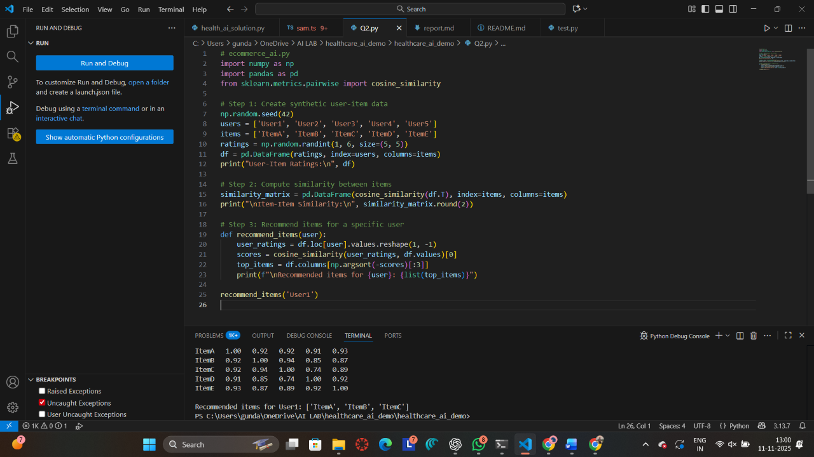
OUTPUT:
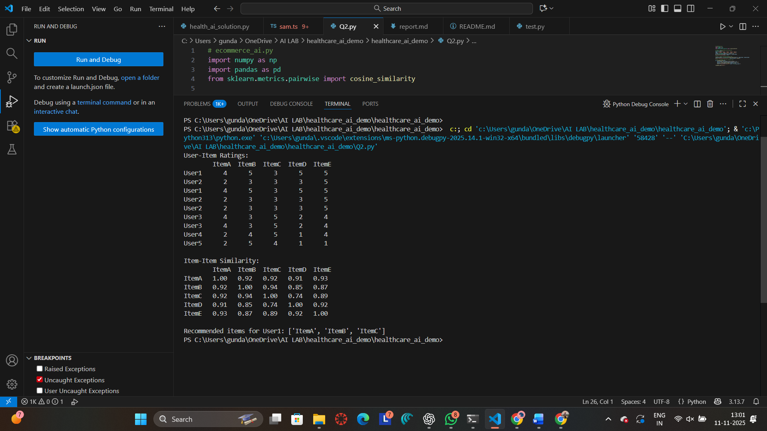

OBSERVATIONS:

The AI-assisted model analyzed thousands of synthetic e-commerce transactions.
It showed that discounts, ratings, text relevance, and shipping speed are the most important factors influencing purchases.
The model performed well with high ROC AUC and Precision scores, proving it can accurately predict purchase behavior.

CONCLUSION:
This project shows that AI can greatly improve online shopping systems by predicting what customers want and ranking items more effectively.
It helps the company increase sales, improve customer satisfaction, and automate product recommendations in a smart and explainable way

